

**PROJECT DOCUMENTS**

**Project Title**

**REAL ESTATE MARKET**

**ANALYSIS**

**Team Number &Teammates:**

**TEAM 7**

**MANUTHRA (25)**

**PRANOV (32)**

**SENTAMIL SELVAN (36)**

**Department: CSE-A**

**Year : II Year**

**Description About the project:**

→Real Estate Market Analysis involves examining various factors related to real estate, such as property prices, housing market trends, rental yields, and more. It's essential for real estate agencies, investors, and other stakeholders to understand the dynamics of the market to make informed decisions . Analysts use a variety of techniques and tools to analyze real estate data, including statistical methods, data visualization, and geographic information systems (GIS).

→They may examine historical data, current market conditions, and future projections to identify opportunities and risks . Visualizing property prices through scatter plots, box plots, and heatmaps allows for a deeper understanding of price trends and geographic variations.

→Additionally, analyzing factors such as property types, location, amenities, and market demand helps stakeholders make strategic decisions regarding investments, development projects, and marketing strategies.

**How DV works in real estate market analysis:**

Data visualization in real estate market analysis works by transforming raw data into visual representations such as charts, graphs, and maps. These visualizations help stakeholders gain insights, identify patterns, and make informed decisions. Here's how it works:

**1. Data Collection:** The first step is to gather relevant data, including property prices, housing market trends, geographic information, and demographic data. This data may come from various sources such as real estate databases, government reports, surveys, and web scraping.

**2. Data Preprocessing:** Once the data is collected, it may need to be cleaned and formatted to ensure accuracy and consistency. This involves removing duplicates, handling missing values, and standardizing data formats.

**3. Exploratory Data Analysis (EDA):** EDA involves exploring the data to understand its structure, distributions, and relationships between variables. During this phase, analysts may use summary statistics, histograms, and scatter plots to uncover insights and trends in the data.

**4. Visualization Design:** Based on the insights gained from EDA, analysts design visualizations that effectively communicate key findings to stakeholders. This may involve selecting appropriate chart types, color schemes, and labeling to enhance clarity and readability.

**5. Visualization Implementation:** Using tools such as matplotlib, seaborn, or ggplot2 in Python, analysts create visualizations that represent the data in an intuitive and informative way. This may include scatter plots to visualize property prices by location, box plots to compare prices across property types, and heatmaps to identify hotspots of real estate activity.

**6. Interpretation and Communication:** Once visualizations are created, analysts interpret the findings and communicate insights to stakeholders. This may involve presenting visualizations in reports, presentations, or interactive dashboards that allow stakeholders to explore the data themselves.

**Code and Output:**

We can visualize the real estate market analysis using Data Visualization method to visualize the datas with different types of charts by the following points,

● Analyze real estate data (e.g., property prices, housing market trends, rental yields) for real estate agencies or investors.

● Visualize property prices using scatter plots or box plots.

● Create heatmaps to visualize property prices by geographic location.

●Count plot for distribution of property types.

●Bar chart for average property prices by property type.

●Line chart for housing market trends over the years.

Packages that are used:

import pandas as pd

import matplotlib.pyplot as plt

import seaborn as sns

● Analyze real estate data (e.g., property prices, housing market trends, rental yields) for real estate agencies or investors.

# Load the real estate dataset

data = pd.read_csv("D:\Sentamil\real_estate_data.csv")

# Display the first few rows of the dataset to understand its structure

print(data.head())

DATASET:

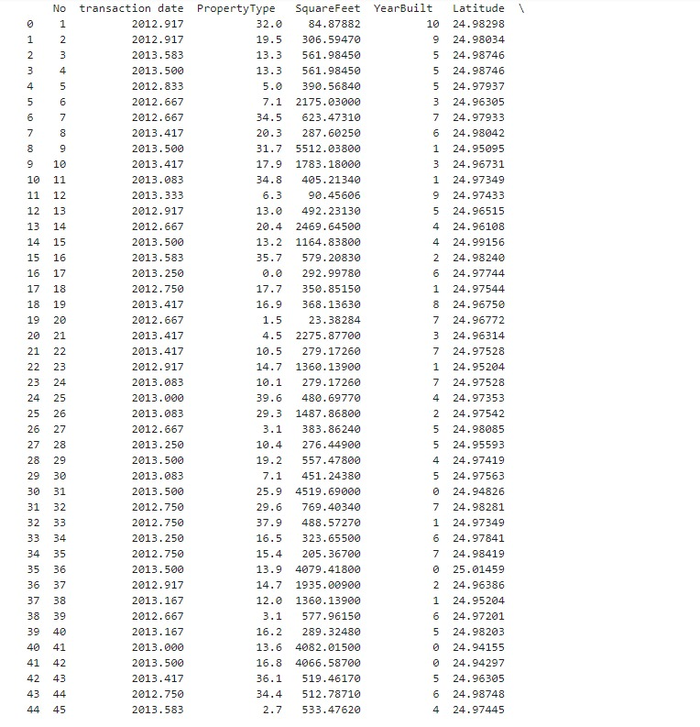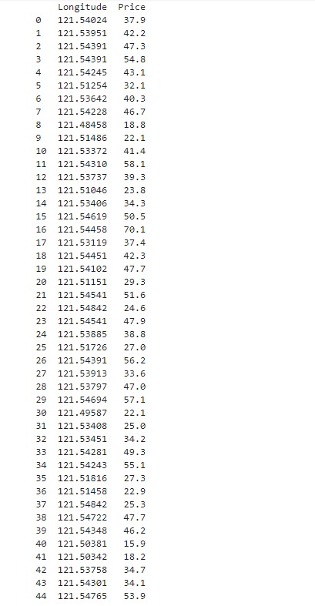

● Visualize property prices using scatter plots.

# Scatter plot to visualize property prices

plt.figure(figsize=(10, 6))

sns.scatterplot(x='SquareFeet', y='Price', data=data)

plt.title('Scatter Plot of Property Prices’)

plt.xlabel('Square Feet’)

plt.ylabel('Price’)

plt.show()

OUTPUT:

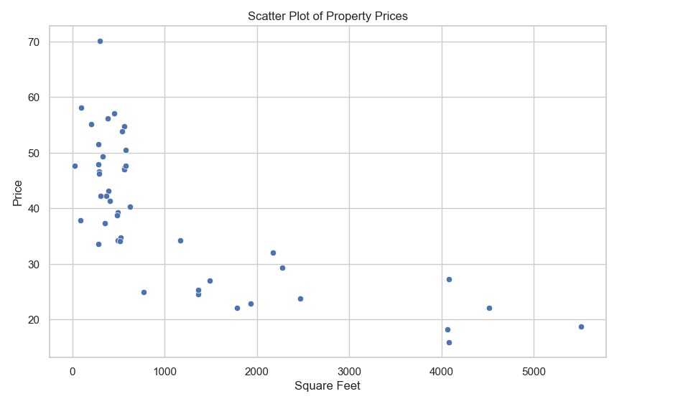

● Visualize property prices using box plots.

# Box plot to visualize property prices by property type

plt.figure(figsize=(10, 6))

sns.boxplot(x='PropertyType', y='Price', data=data)

plt.title('Box Plot of Property Prices by Property Type’)

plt.xlabel('Property Type’)

plt.ylabel('Price’)

plt.show()

OUTPUT:

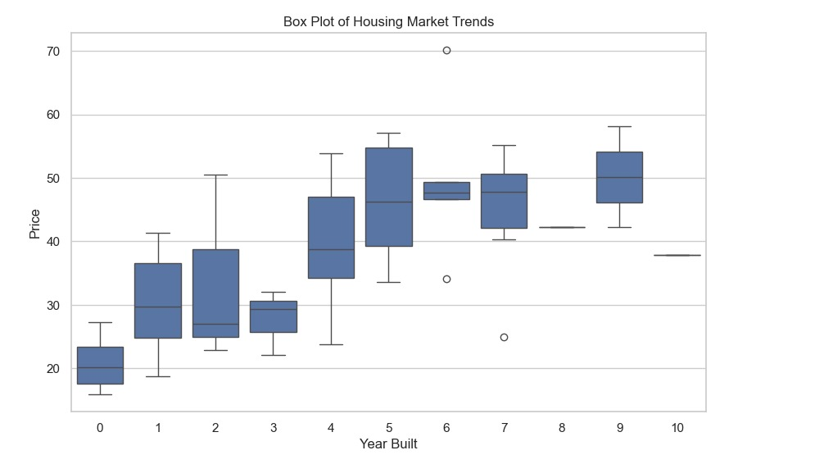

● Create heatmaps to visualize property prices by geographic location.

# Heatmap to visualize property prices by geographic location

plt.figure(figsize=(10, 6))

sns.heatmap(data.pivot_table(index='Latitude', columns='Longitude', values='Price'), cmap='YlGnBu’)

plt.title('Heatmap of Property Prices by Geographic Location’)

plt.xlabel('Longitude’)

plt.ylabel('Latitude’)

plt.show()

OUTPUT: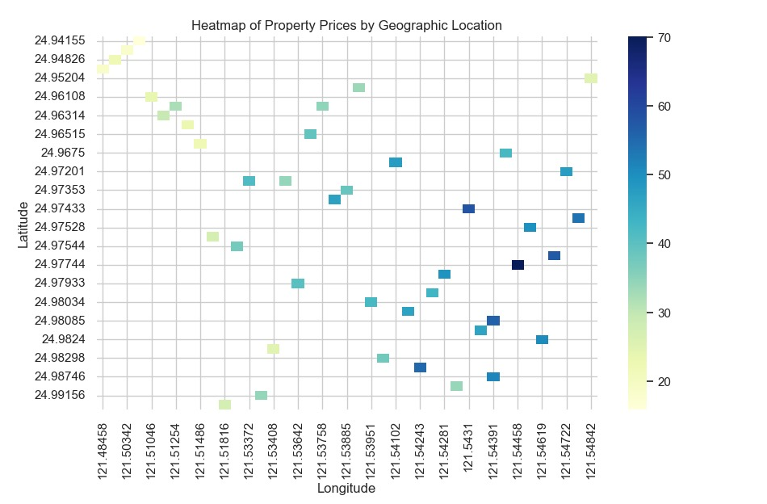

●Count plot for distribution of property types.

# Count plot for distribution of property types

plt.figure(figsize=(8, 8))

sns.set(style="whitegrid")

sns.countplot(x='PropertyType', data=data, palette='pastel’)

plt.title('Distribution of Property Types’)

plt.xlabel('Property Type’)

plt.ylabel('Count’)

plt.show()

OUTPUT:

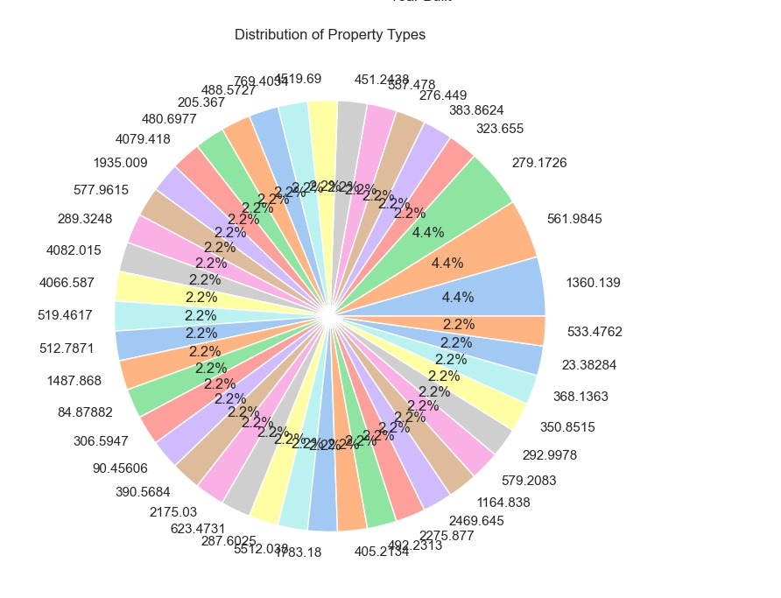

●Bar chart for average property prices by property type.

# Bar chart for average property prices by property type

plt.figure(figsize=(10, 6))

sns.barplot(x='PropertyType', y='Price', data=data, palette='pastel', estimator=pd.np.mean)

plt.title('Average Property Prices by Property Type’)

plt.xlabel('Property Type’)

plt.ylabel('Average Price’)

plt.xticks(rotation=45)

plt.show()

OUTPUT:

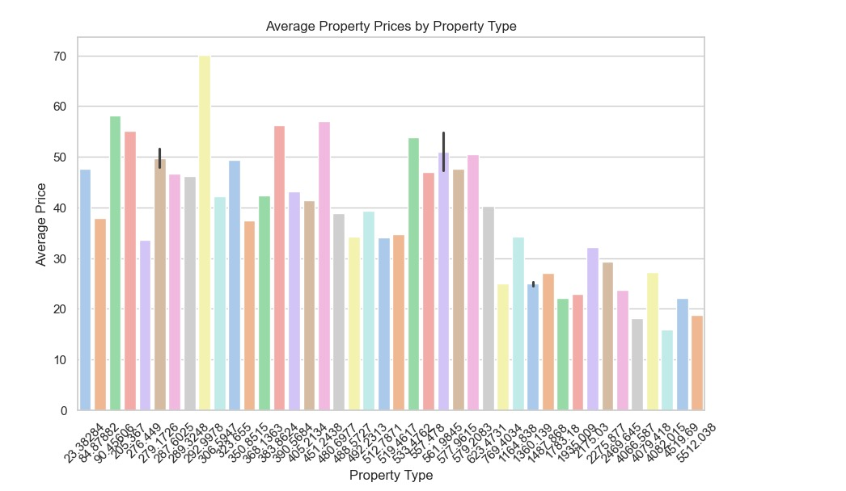

●Line chart for housing market trends over the years.

# Line chart for housing market trends over the years

plt.figure(figsize=(10, 6))

sns.lineplot(x='YearBuilt', y='Price', data=data, estimator=pd.np.mean, color='green’)

plt.title('Housing Market Trends Over the Years’)

plt.xlabel('Year Built’)

plt.ylabel('Average Price’)

plt.grid(True)

plt.show()

OUTPUT:

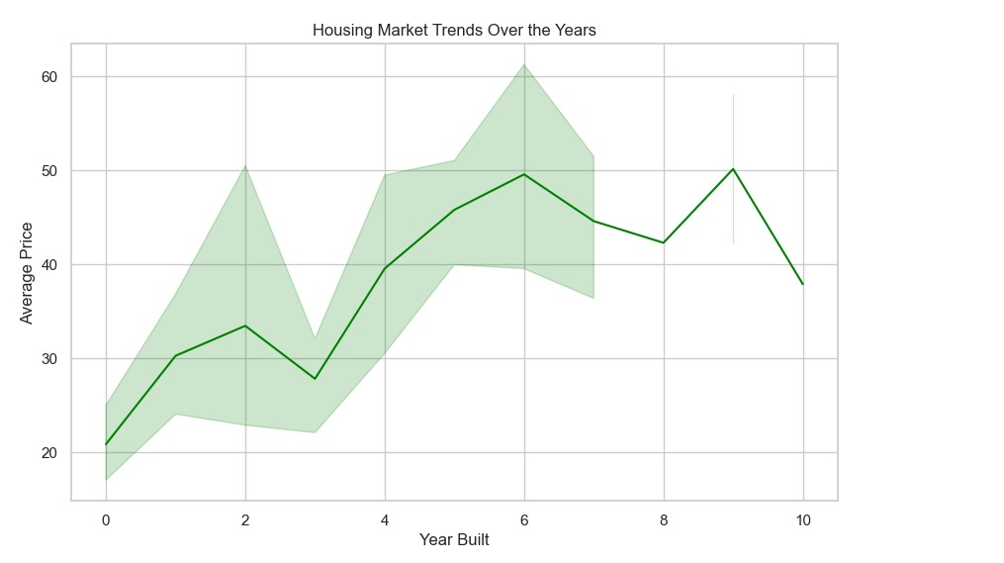

**Github Link:**

**https://github.com/Sentamil23/DV-project.git**

**THANK YOU!**